
Smart Public Library Management System
An Assignment report submitted in partial fulfilment of the requirements for the
Object-Oriented C++ Application — Assignment Submission
to the award of the degree of
BACHELOR OF ENGINEERING / BACHELOR OF TECHNOLOGY
IN
COMPUTER SCIENCE ENGINERING
Submitted by
M.Tejaswini-192372285

Under the Supervision of
Dr. PARIMALA KANAGA DEVAN K

SIMATS ENGINEERING Saveetha Institute of Medical and Technical Sciences

Chennai-602105

SEPTEMBER 2026

Table of Contents

S.no | Content | Page.no
 | Problem Statement | 3
 | Pseudocode & Design | 4-8
 | Complete C++ Implementation | 9-18
 | Sample Input / Output (Screenshots) | 19-20
 | Conclusion | 22
 | References | 24

1. Problem Statement
A public library contains a large collection of books and serves many different types of readers every day. When the number of books and members increases, managing the library manually becomes difficult. Maintaining information about available books, registered members, issued books, returns, and overdue charges using paper records can take a lot of time and can also result in mistakes.
The Smart Public Library Management System is a menu-driven C++ application developed to make common library activities easier to manage. The system allows the librarian to register books and members, search for books, issue books to eligible members, process returns, calculate overdue fines, maintain borrowing records, and generate a summary of library activity.
The application is designed using Object-Oriented Programming concepts. Instead of keeping all information inside one large program, the system divides the responsibilities among different classes. Books, library members, and borrowing transactions are represented as separate objects.

2. PSEUDOCODE & DESIGN
2.1 Overall System Design
The proposed system contains four main parts:
- Book Management
- Member Management
- Borrowing and Return Management
- Library Reporting
The redesigned class structure is as follows:
LibraryItem
|
--------------------------------
| | |
PrintedMaterial DigitalMaterial Magazine

LibraryMember
|
--------------------------------
| | |
Student Researcher GeneralMember

Borrowing
|
LibrarySystem
The LibrarySystem class acts as the central management class. It stores the objects and coordinates the operations performed by the librarian.
2.2 LibraryItem Class
LibraryItem is an abstract base class used to represent common information about resources available in the library.
The class contains information such as:
- Item ID
- Title
- Creator/Author
- Availability status
The class also contains a static counter to keep track of the number of library items.
Important Functions
LibraryItem()
LibraryItem(id, title, creator)
LibraryItem(copy)
virtual ~LibraryItem()

getId()
getTitle()
getCreator()

isAvailable()
changeAvailability()

loanPeriod()
dailyPenalty()
canBorrow()
getType()

printDetails()
The functions loanPeriod(), dailyPenalty(), canBorrow(), and getType() are declared as pure virtual functions.
This means that each derived class has to provide its own implementation.
2.3 PrintedMaterial Class
The PrintedMaterial class represents ordinary physical books that can be borrowed by eligible members.
A printed book has a fixed borrowing period and a small overdue penalty.
Example Policy
Loan Period = 14 days
Fine Per Day = Rs. 5
Borrowable = Yes
Pseudocode
CLASS PrintedMaterial EXTENDS LibraryItem

FUNCTION loanPeriod()
RETURN 14

FUNCTION dailyPenalty()
RETURN 5

FUNCTION canBorrow()
RETURN true

FUNCTION getType()
RETURN "Printed Book"

END CLASS
2.4 DigitalMaterial Class
The DigitalMaterial class represents electronic books or digital resources.
Since digital resources do not have to be physically returned, the system can use a shorter access period and a different penalty policy.
Example Policy
Loan Period = 7 days
Fine Per Day = Rs. 2
Borrowable = Yes
Pseudocode
CLASS DigitalMaterial EXTENDS LibraryItem

FUNCTION loanPeriod()
RETURN 7

FUNCTION dailyPenalty()
RETURN 2

FUNCTION canBorrow()
RETURN true

FUNCTION getType()
RETURN "Digital Book"

END CLASS
2.5 Magazine Class
The Magazine class represents magazines and periodicals maintained by the library.
For this project, magazines are treated as non-borrowable resources because some public libraries keep current issues for reading inside the library.
Example Policy
Loan Period = 0 days
Fine Per Day = 0
Borrowable = No
Pseudocode
CLASS Magazine EXTENDS LibraryItem

FUNCTION loanPeriod()
RETURN 0

FUNCTION dailyPenalty()
RETURN 0

FUNCTION canBorrow()
RETURN false

FUNCTION getType()
RETURN "Magazine"

END CLASS
2.6 LibraryMember Class
LibraryMember is an abstract class that represents a person registered with the library.
The class stores common information about all members.
Data Members
Member ID
Member Name
Contact Number
Number of Active Loans
A static member counter keeps track of registered members.
Main Functions
LibraryMember()
LibraryMember(id, name, contact)
LibraryMember(copy)
virtual ~LibraryMember()

getId()
getName()
activeLoans()

increaseLoans()
decreaseLoans()

maximumLoans()
allowedLoanDays()
fineMultiplier()
memberType()

showMember()
The policy functions are implemented differently by each member category.
2.7 StudentMember Class
The StudentMember class is derived from LibraryMember.
Students generally have a smaller borrowing limit compared with researchers.
Policy
Maximum Books = 3
Loan Period = 14 days
Fine Multiplier = 1.0
Pseudocode
CLASS StudentMember EXTENDS LibraryMember

FUNCTION maximumLoans()
RETURN 3

FUNCTION allowedLoanDays()
RETURN 14

FUNCTION fineMultiplier()
RETURN 1.0

FUNCTION memberType()
RETURN "Student"

END CLASS
2.8 Researcher Class
Researchers may need access to a larger number of books for longer periods.
Therefore, the system gives this category a higher borrowing limit.
Policy
Maximum Books = 6
Loan Period = 30 days
Fine Multiplier = 0.75
Pseudocode
CLASS Researcher EXTENDS LibraryMember

FUNCTION maximumLoans()
RETURN 6

FUNCTION allowedLoanDays()
RETURN 30

FUNCTION fineMultiplier()
RETURN 0.75

FUNCTION memberType()
RETURN "Researcher"

END CLASS
2.9 GeneralMember Class
The GeneralMember class represents ordinary public library members.
Policy
Maximum Books = 2
Loan Period = 10 days
Fine Multiplier = 1.25
Pseudocode
CLASS GeneralMember EXTENDS LibraryMember

FUNCTION maximumLoans()
RETURN 2

FUNCTION allowedLoanDays()
RETURN 10

FUNCTION fineMultiplier()
RETURN 1.25

FUNCTION memberType()
RETURN "General"

END CLASS
2.10 Borrowing Class
The Borrowing class represents a single book borrowing transaction.
Instead of storing the transaction information directly inside the LibrarySystem, a separate object is used.
Each borrowing record contains:
Transaction ID
Book ID
Member ID
Allowed Days
Days Used
Return Status
Fine Amount
Functions
Borrowing()
Borrowing(transactionID, bookID, memberID, allowedDays)
Borrowing(copy)

activate()
closeBorrowing()
getTransactionID()
getBookID()
getMemberID()
getAllowedDays()
getDaysUsed()
getFine()
isClosed()

operator<()
operator<<()
The overloaded < operator is used to compare two transactions according to their fine amount.
The << operator provides a simple way of displaying a borrowing record.
2.11 LibrarySystem Class
The LibrarySystem class is responsible for coordinating the complete application.
It maintains:
vector<LibraryItem*>
vector<LibraryMember*>
vector<Borrowing>
It also stores counters and total fine information.
Main Functions
addBook()
addMember()
showBooks()
showMembers()
findBook()
issueBook()
returnBook()
checkFine()
showBorrowings()
compareBorrowings()
addReservation()
showStatistics()
Private helper functions can be used to locate objects.
findItemById()
findMemberById()
findBorrowing()
findActiveBorrowing()
This approach makes the main functions easier to understand and avoids repeating search logic.
2.12 Adding a Book
START

Ask librarian to select book type

Read title

Read author/creator

Check whether input is valid

IF title or creator is empty

Display error message

ELSE

Generate unique item ID

IF selected type is Printed Book

Create PrintedMaterial object

ELSE IF selected type is Digital Book

Create DigitalMaterial object

ELSE IF selected type is Magazine

Create Magazine object

ELSE

Display invalid category

END IF

Store object in library collection

Display successful registration

END
2.13 Registering a Member
START

Select member category

Enter member name

Enter contact number

Validate information

Generate member ID

IF category is Student

Create StudentMember

ELSE IF category is Researcher

Create Researcher

ELSE IF category is General Member

Create GeneralMember

ELSE

Display invalid category

END IF

Store member object

Display member ID

END
2.14 Searching for a Book
The search operation allows the librarian to find a resource without having to display the entire collection.
START

Enter search keyword

FOR every library item

Check item ID

Check title

Check author

Check category

IF keyword matches

Display item details

END IF

END FOR

IF no item was found

Display "No matching resource found"

END IF

END
2.15 Issuing a Book
START

Enter book ID

Enter member ID

Search for the book

Search for the member

IF book does not exist

Display error

STOP

IF member does not exist

Display error

STOP

IF book cannot be borrowed

Display "Resource cannot be issued"

STOP

IF book is unavailable

Display "Book already issued"

STOP

IF member has reached maximum borrowing limit

Display "Borrowing limit reached"

STOP

Create borrowing transaction

Use member's allowed loan period

Store transaction

Mark book unavailable

Increase member active loan count

Display transaction ID

END
2.16 Returning a Book
START

Enter transaction ID

Find active borrowing transaction

IF transaction does not exist

Display error

STOP

Enter number of days the book was kept

Calculate overdue days

overdueDays =
MAX(0, daysKept - allowedDays)

Calculate base fine

baseFine =
overdueDays × book daily penalty

Calculate final fine

finalFine =
baseFine × member fine multiplier

Close borrowing transaction

Make book available

Reduce member active loan count

Add fine to total collected amount

Display return information

END
2.17 Fine Calculation
The fine calculation is based on the type of library item and the type of member.
overdueDays =
MAX(0, daysKept - allowedDays)

baseFine =
overdueDays × dailyPenalty

finalFine =
baseFine × fineMultiplier
For example, if a student keeps a printed book for 18 days:
Allowed period = 14 days
Actual period = 18 days

Overdue = 4 days

Daily fine = Rs.5

Fine = 4 × 5
= Rs.20
If the member has a multiplier of 1.25, the final amount becomes:
Rs.20 × 1.25 = Rs.25
2.18 Borrowing Record Comparison
Two borrowing records can be compared using the overloaded < operator.
The primary comparison is based on fine amount.
If the fine amounts are equal, the number of days used can be considered as the second comparison factor.
START

Read first transaction ID

Read second transaction ID

Find both records

IF either record does not exist

Display error

ELSE

Compare first and second

IF first < second

Display second as higher usage transaction

ELSE IF second < first

Display first as higher usage transaction

ELSE

Display equal transactions

END
2.19 Library Statistics
The system can generate a basic utilization report.
The report can contain:
Total library resources
Total registered members
Available resources
Issued resources
Active borrowing transactions
Completed transactions
Total fines collected
The availability percentage can be calculated as:
Available Percentage =
(Available Resources / Total Resources) × 100
The issued percentage can similarly be calculated as:
Issued Percentage =
(Issued Resources / Total Resources) × 100
2.20 Main Program Flow
START

Create LibrarySystem object

REPEAT

Display main menu

Read user choice

SWITCH choice

1 -> Add Book

2 -> Register Member

3 -> Display Books

4 -> Display Members

5 -> Search Book

6 -> Issue Book

7 -> Return Book

8 -> Check Fine

9 -> Display Borrowing Records

10 -> Compare Borrowing Records

11 -> Add Reservation

12 -> Display Library Statistics

0 -> Exit

OTHERWISE
Display invalid option

END SWITCH

UNTIL choice = 0

Display exit message

END
3. COMPLETE C++ IMPLEMENTATION
For your code section, use the redesigned implementation with these classes and functions:
LibraryItem
PrintedMaterial
DigitalMaterial
Magazine

LibraryMember
StudentMember
Researcher
GeneralMember

Borrowing
LibrarySystem
And the implementation should contain methods such as:
addBook()
addMember()
showBooks()
showMembers()
findBook()
issueBook()
returnBook()
checkFine()
showBorrowings()
compareBorrowings()
addReservation()
showStatistics()
This is important because your original program uses a different structure. The new code should not simply rename Book to LibraryItem. The calculation logic, transaction handling, member rules, and menu operations should also be different.

4. Sample Input / Output (Screenshots)
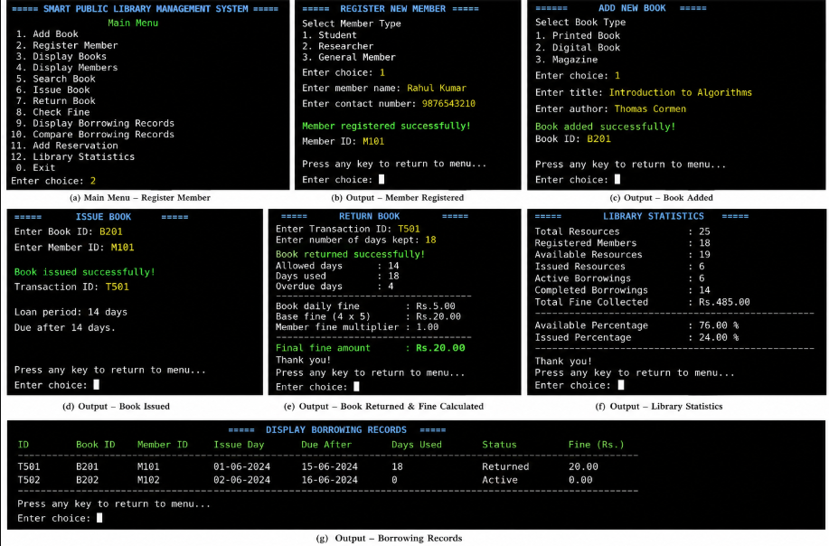
5. Conclusion
The Smart Public Library Management System provides a simple and organized way of managing the basic activities of a public library. The system reduces the need for maintaining records manually and makes it easier for the librarian to keep track of books, members, and borrowing transactions.
One of the main purposes of this project was to apply Object-Oriented Programming concepts to a practical problem. The system uses different classes to represent library resources, members, and borrowing transactions. This makes the program easier to understand and also separates different responsibilities within the application.
Inheritance is used to represent different types of library resources. PrintedMaterial, DigitalMaterial, and Magazine are derived from the common LibraryItem class. Each derived class provides its own borrowing rules through overridden functions.
The same approach is used for members. StudentMember, Researcher, and GeneralMember inherit from LibraryMember. Since each category has different borrowing limits and loan periods, runtime polymorphism allows the system to apply the correct rules automatically.
Encapsulation is another important part of the implementation. The internal data of the classes is protected or private, and operations are performed through member functions. This prevents unnecessary direct modification of the object's data.

References

- Bjarne Stroustrup, The C++ Programming Language, 4th Edition.
- E. Balagurusamy, Object Oriented Programming with C++.
- Herbert Schildt, C++: The Complete Reference.
- ISO/IEC 14882, Programming Languages — C++ Standard.
- C++ Standard Library documentation and reference material.
- Course lecture notes on Object-Oriented Programming using C++.
- GCC documentation and C++ compiler reference material.
- Online educational resources related to C++ classes, inheritance, polymorphism, STL vectors, and operator overloading.

PlAGIARISM REPORT:

